Resources for Learning Morse Code

This document collects together useful resources for those beginning their
CW journey and for those that wish to improve their speed and proficiency.

Hamfesters Amateur Radio Club

Document Distribution TLP:WHITE
Document Classification: Not Classified

This document was created using Microsoft Word 2016 in landscape with ½” left and right margins. If you edit this document in OpenOffice or LibreOffice, you will have to tweak page, TOC, and table widths.

Version 1.1b
Created 2021-02-09 @ 17:00 by AB9MZ
Updated 2021-03-04 @ 15:00 by AB9MZ

Edited by Gregory D. Rosenberg (AB9MZ)
Please send any corrections or additions to ab9mz@arrl.net.

+1 708-444-2690 Office
+1 708-267-6664 Mobile
All information in this document is public domain.
Any copyrighted material has been credited with its source.
Table of Contents
Table of Tables 5
Table of Figures 6
Table of Authorities 6
Who is this document for? 7
Document Revision History 7
Why Choose CWOps Academy 8
The 6 Bad Habits of CW: 9
Daily Morse Code “Scales” Sending Warm Up 11
Understanding Universal Coordinated Time (UTC) and Daylight Savings Time 12
UTC, GMT and Daylight-Saving Time 12
Slow Speed CW Nets 13
W1AW Operating Schedule, CW Speeds, and Frequencies 15
Morse Code - Web Resources 16
Learning and Resource Websites 16
Morse Code - Learning and Reference Software 17
Software that runs on Microsoft Windows 17
Software that runs on Windows or Mac OS 17
Software that runs on Windows, Mac OS, or Linux 18
MP3 Player Practice Files 18
Amazon Alexa Skills 19
Software that runs on Apple iOS and iPadOS 19
Software that runs on Google Android OS 19
U.S. Army Training Video from 1966 20
Social Media Sites 20
Facebook 20
CW Ops 20
CW.QRS 20
Appendix A – CW Operating Aids 21
Morse Code Timing Rules 22
The most common CW abbreviations Q-codes, Prosigns, and most used words. 23
United States – State, Territory, and Commonwealth Abbreviations 24
The Most Common Procedural Signs (or Prosigns) for Morse Code 25
CW Abbreviations 27
Q-Codes 29
RST (Readability Signal Tone) 31
Appendix B - How to Make a Short CW Contact 32
Appendix C - Morse Code Ninja’s Advice for Beginners and Beyond 34
DOs 34
DON’Ts 35
So, you want to go faster: 36
Levels of Morse code proficiency: 37
1. Conscious decoding of Dits and Dahs in Your Head 37
2. Instant Character Recognition (ICR) 38
3. Instant Word Recognition (IWR) 40
4. Focus on the Meaning of the Message 41
The Dirty Dozen: 42
Appendix D - Morse Code History 45
Morse code receiver, recording on paper tape 45
Comparison of historical versions of Morse code with the current standard. 46
A U.S. Navy Morse Code training class in 2015. The sailors will use their new skills to collect signals intelligence. 47
Appendix E - Here are some commonly heard CW sender spacing errors 48
Ti ming is ever y thing 48
Sending Proficiency 49
Appendix F– Other CW References 50
Books 51
Appendix G - CW Reverse Beacon Network 52
CW Reverse Beacon Network 52
Reverse Beacon Network 53
What Beacons are Being Heard? 53
Appendix H - Acknowledgements 54
INDEX 55

Table of Tables
Table 1 Document Change History 7
Table 2 Slow Speed CW Nets 14
Table 3 W1AW Operating Schedule 15
Table 4 Learning and Resource Websites 17
Table 5 Software that runs on Microsoft Windows. 17
Table 6 Software that runs on Microsoft Windows or Apple Mac OS 18
Table 7 Software that runs on Microsoft Windows, Apple Mac OS, or Linux 18
Table 8 MP3 Player Resources. 18
Table 9 Amazon Alexa Skills. 19
Table 10 Software that runs on Apple iOS and iPadOS 19
Table 11 Software that runs on Google Android OS. 19
Table 12 U.S. Army Training Video from 1966 20
Table 13 United States – State, Territory, and Commonwealth Abbreviations. 24
Table 14 Commonly used Procedural Signs (Prosigns). 25
Table 15 Additional procedural signs. 26
Table 16 Use cut numbers 5NN instead of 599 during a contest. 31
Table 17 Signal Report (Readability, Signal Strength, and Tone) (RST)) 31
Table 18 How to Make a Short CW Contact (1 of 2). 32
Table 19 How to Make a Short CW Contact (2 of 2). 33
Table 20 Copying Methods. 39
Table 21 The ABC's of success 40
Table 22 The Dirty Dozen. 44
Table 23 Books about Morse Code. 51

Table of Figures
Figure 1 Savvytime Time conversion sample screen shot. 12
Figure 2 Morse Code Spacing and Timing Elements. 22
Figure 3 The most common CW abbreviations Q-codes, Prosigns, and most used words. 23
Figure 4 Full list of CW abbreviations (1 of 2). 27
Figure 5 Full list of CW abbreviations (2 of 2). 28
Figure 6 Q-Codes (Q-Signals). 29
Figure 7 QN-Codes (QN-Signals) 30
Figure 8 Morse code speed vs proficiancy. 36
Figure 9 CW Reverse Beacon Network. 52
Figure 10 NCDXF Reverse Beacon Network 53

Table of Authorities
Authority
Federal Communications Commission (FCC) 47
International Telecommunications Union (ITU) 46

Who is this document for?
This document is for anyone curious about Morse code, but it also has lots of resources for improving your CW speed and proficiency. If you are unfamiliar with Morse Code, I have included several appendixes with resources to help you along your journey. Appendix A contains useful CW learning and operating aids. Appendix B provides an example of a short CW contact. Appendix C offers the Morse Code Ninja’s advice for beginners and beyond. Appendix D briefly covering the history and development of Morse code. Appendix E contains some commonly heard CW sender spacing errors. Appendix F has some additional references. Appendix G provides information about CW Reverse Beacon Networks.

Document Revision History
This table lists all significant changes to this document.
Date | Version | By | Description of Change
2021-02-24 | 1.0 | Gregg (AB9MZ) | Original draft document
2021-02-25 | 1.1 | Gregg (AB9MZ) | Published document
2021-03-04 | 1.1b | Gregg (AB9MZ) | Added the Long Island NY CW Club per Kurt AD0WE. Added information about CW Reverse Beacon Networks.
Table 1 Document Change History

Why Choose CWOps Academy
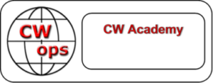
For the beginner
- Want to communicate with fellow hams around the world using even a modest rig and antenna?
- Want to stay in touch when on vacation to some remote area where you don’t have access to a repeater or cell phone service?
- Want to meet a whole new community of amateurs that share a common bond?
- Want to expand your operating capabilities with little or no cost? If you answer “Yes” to any of the questions, then becoming skilled in CW is the answer. CWops CW Academy advisors are ready and willing to teach you a new skill that will open a world of fun and opportunity
For those having experience with CW who want to improve or regain proficiency
- am getting bored with voice and digital modes
- My CW skills are not what they used to be
- I’m too rusty or embarrassed to get back on CW
- I want to be able to copy in my head
If you know the code but are rusty, can’t copy or send as proficiently as you once could, then CWops CW Academy is right for you
For those that want something new but are not confident to take the plunge
- love chasing DX and I want to try something new
- I like contesting and would like to be better at CW radio sport
- I’ve tried CW learning aids, but nothing seems to work for me
- CW intrigues me but I’m worried about the challenge

If this sounds like you, then CWops CW Academy is absolutely right for you and is available to anyone, anywhere.
There is no cost or obligation to participate in CWops CW Academy Classes and membership is not required. Enrollment is open to anyone with the desire to learn or improve their proficiency in Morse Code.
Please Note: CW Academy training and mentoring for Beginners and those with Morse Code experience needing help are offered three times a year, in two-month increments: January through February, April through May, and September through October.
Sign up and learn what CW Academy can do for you.
https://cwops.org/cw-academy/cw-academy-options.

The 6 Bad Habits of CW:
Our CWOps Academy Instructor Ken (AC5EZ) provided the following list of bad habits of CW..
- Counting dits and dahs: The best way to stop counting dits and dahs is to keep the character speed at 25 to 30 wpm or above. Farnsworth adds extra spacing between the characters to slow down the actual speed. Start by using a Farnsworth setting of around 4. Then slowly increase your Farnsworth setting over time as your brain learns the rhythm of each code character.
- Mental lookup table (and other extra steps): You must eliminate every mental process between hearing the characters and recognizing them. The Morse character must be equivalent to the sound of the character itself in your mind. You hear di-di-dah-dit, and F pops into your mind. No extra steps!
- Holding on to unrecognized characters: You must drop missed characters immediately in order to be ready for the next character. This “Letting Go” is a skill that takes practice and requires you to get comfortable missing characters. Always be ready for the next character - MISS FAST!
- DO NOT pause and ponder!
- Crutches – Pencils, decoders, etc.: These “tools” destroy your goal of comfortably copying the code. They are not “training wheels.” They are a hard obstacle. Just close your eyes and listen. Relax about missed characters – that’s not a failure; it’s normal. Get used to it!
- Not Getting on the Air: You may think “When I improve my CW proficiency I’ll get on the air.” The truth is: “When I get on the air, I will improve my CW proficiency.”
NOTE: See Appendix C - Morse Code Ninja’s Advice for some useful DOs and DON’Ts.
When Copying and Sending CW
RELAX and CLOSE YOUR EYES:
At first, you will certainly write down all incoming letters. But you should try to relax and copy in your head. As your skill evolves you will start to recognize words and later phrases. It will take you some time to get to that point. For example. when the other station starts to describe their station. Part of the text may well be a description of his antenna. So, you can expect him/her to say, "the antenna here is a dipole up 40 feet". So as the letters arrive there is no need to write this phrase down. You are starting to copy in your head. Soon you will expand your skill in copying without writing down everything. Practice by listening to other slow speed CW QSOs and see how much you can copy in your head. You may be surprised. Do this while you are working in the shack with your shortwave receiver on. Listen to the ongoing QSO in the background. You will begin to pick up words and phrases. With practice you will be copying more and more in your head. This will greatly enhance the pleasure of conversing in Morse Code. Becoming a good skilled CW operator is proud feeling and if you are into DXing or contesting, worth much to your success.
THERE ARE NO SHORTCUTS:
Instant Character Recognition is the foundation of CW Head Copy. Keep practicing Instant Character Recognition throughout this course and beyond!
PRACTICE, PRACTICE, PRACTICE!

Daily Morse Code “Scales” Sending Warm Up
Bob Carter – (WR7Q) 2018-12-09
- Do the “Warm Up” every day before you send anything
- Do the “Exercise” as needed…to get better at letters and numbers
- Do the “Drill” as needed…to increase your sending skills
Send all five characters in each character group or each word without error or start “it” again!
IMPORTANT: Spaces below are for readability only. You should ignore them when sending your code.
Warm Up
EEEEE TTTTT IIIII MMMMM SSSSS OOOOO HHHHH 00000 55555
AAAAA NNNNN UUUUU DDDDD VVVVV BBBBB 44444 66666
ABCDEF GHIJK LMNOP QRSTU VWXYZ 12345 67890 / , . ?
THE QUICK BROWN FOX JUMPS OVER THE LAZY DOGS BACK 7 0 3 6 4 5 1 2 8 9
Exercise
AAAAA BBBBB CCCCC DDDDD EEEEE FFFFF GGGGG HHHHH IIIII JJJJJ
KKKKK LLLLL MMMMM NNNNN OOOOO PPPPP QQQQQ RRRRR
SSSSS TTTTT UUUUU VVVVV WWWWW XXXXX YYYYY ZZZZZ
11111 22222 33333 44444 55555 66666 77777 88888 99999 00000
Drill
THE QUICK BROWN FOX JUMPS OVER THE LAZY DOGS BACK 7 0 3 6 4 5 1 2 8 9
THE QUICK BROWN FOX JUMPS OVER THE LAZY DOGS BACK 7 0 3 6 4 5 1 2 8 9
BENS BEST BENT WIRE/5 BENS BEST BENT WIRE/5 BENS BEST BENT WIRE/5
///// ,,,,, ..... ????? +++++ =====
$\overline{AK}$ $\overline{AR}$ $\overline{BK}$ $\overline{BT}$ $\overline{HH}$ $\overline{SK}$

Understanding Universal Coordinated Time (UTC) and Daylight Savings Time
All times are provided in Universal Coordinated Time (UTC). Some refer to it a Coordinated Universal Time (CUT) or Zulu (Z). Greenwich Mean Time (GMT) is often interchanged or confused with Coordinated Universal Time (UTC). One key difference is that GMT ¹ is a time zone and UTC is a time standard.
- GMT is a time zone officially used in some European and African countries. The time can be displayed using both the 24-hour format (0 - 24) or the 12-hour format (1 - 12 am/pm).
- UTC is not a time zone, but a time standard that is the basis for civil time and time zones worldwide. This means that no country or territory officially uses UTC as a local time.

UTC, GMT and Daylight-Saving Time
Neither UTC nor GMT ever change for Daylight Saving Time (DST). However, some of the countries that use GMT switch to different time zones during their DST period. For example, the United Kingdom is not on GMT all year, it uses British Summer Time (BST), which is one hour ahead of GMT, during the summer months. I have provided a link to my favorite time zone converters ².
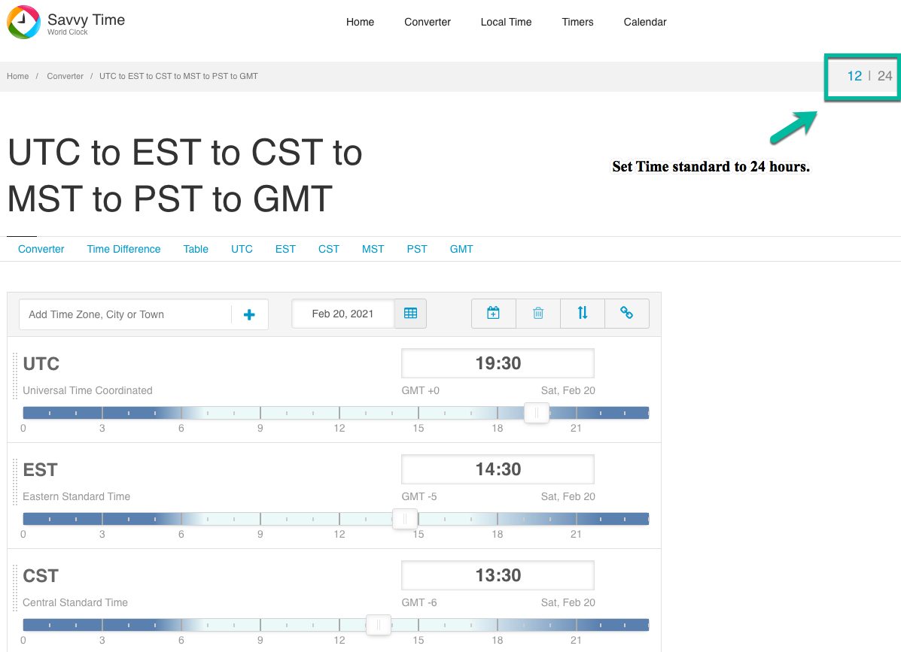
Figure 1 Savvytime Time conversion sample screen shot.
Sources:
(1) https://dateandtime.com
(2) https://savvytime.com/converter/utc-to-est-cst-mst-pst-gmt or https://www.worldtimeserver.com/time-zones/z/

Slow Speed CW Nets
Updated 2021-02-15
NET / SOURCE | PURPOSE | FREQ +/- | Time UTC | DAYS | Net Control Station and Notes
Carolina Slow Net (CSN)¹ | Traffic/Practice | 3.571.00 | 01:00Z | Daily | W4EAT
Empire Slow Speed (ESS) | Traffic/Training | 3.576.00 | 23:00Z | Daily | WI2G
Florida Med.Speed Net | Traffic/Training | 3.552.00 | 23:30Z | Daily | AG4RJ
Georgia CW Training Net¹ | Traffic/Training | 3.549.00 | 02:00Z | Daily | WE4GA
Hit and Bounce Slow Net¹ | Traffic/Training | 7.112.00 | 12:30Z1 | Daily | N7MPS
Hoodview CW Net² | CW Practice | 28.130.00 | 00:00Z | Daily | AB7BI
Idaho Montana CW Net² | Traffic/Training | 3.647.00 | 00:00Z | Daily | N7MPS
K9YA Slow Net¹ | Practice/Fun | 7.122.00 | 00:00Z | Thursday | N9BOR
LIDS QRS CW Net | Practice | 7.035.00 | None | None | By arrangement
Maine Slow Speed Net¹ | Training | 3.585.00 | 23:00Z | Weekdays | KA1LPW
Maryland CW Slow Net (MSN)¹ | Traffic/Training | 3.563.00 | 00:30Z | Daily | W8CPG
Midsouth CW Training Net | Training | 3.593.00 | 23:00Z | Daily | WD4PTJ
NAQCC QRS Net  East Texas QRS Net (ETN)  MIDWEST QRS Net (MWN)  Pacific Northwest 80 Net (PNW80)  1Land QRS Net (1LND) | Traffic/Training  Summer  Winter | 7.066.00  3.566.00  7.031.00  3.556.50  3.560.00 | 01:00Z  01:00Z  01:30Z  01:00Z  00:00Z | Tuesday  Tuesday  Tuesday  Thursday  2nd/4th Sunday | Allen KA5TJS (TX)  Allen KA5TJS (TX)  Bob W0CC (KS)  Stewart KE7LKW  Ed K1RID (ME)
NARL CW Slow Net | Traffic/Training | 28.180.00 | 00:30Z | Daily | AA1GW
NJ CW Slow Net | Traffic/Training | 3.547.00 | 23:30Z | Daily | K2PB
Northern CA Slow Net¹ | Traffic/Training | 3.705.00 | 02:00Z | Daily | WB6UZX
Ohio CW Slow Net¹ | Traffic/Training | 3.705.00 | 23:10Z | Daily | WD8Q
Oklahoma CW Training Net | Traffic/Training | 7.120.60 | 22:20Z | Daily | WB5KND
Oregon Section Net¹ | Practice/Chat  Traffic/Training  Traffic/Training | 7.085.00  3.587.00  3.587.00 | 14:00Z  03:00Z  02:00Z | Daily  Daily  Daily | KC7SRL  KC7SRL  W7IZ
PA CW Training Net | Code Practice | 3.537.00 | 04:30Z | Daily | N3SW
Sandia Valley Slow Net | Code Practice | 7.063.00 | 02:00Z | Wed | WB7RHT
Tennessee Slow Speed Net | Training | 3.682.00 | 01:30Z | Daily
Texas Slow Net (TSN)¹ | Traffic/Training | 3.552.00 | 00:45Z | Daily | W5ESE
Utah CW Net¹ | Traffic/Training | 3.570.00 | 00:30Z | Daily | NA7G
VE2UMS CW Traffic Net¹ | Traffic | 3.578.00 | 01:00Z | Daily | VE2CBW
West Coast Slow Net¹ | Traffic/Training | 3.540.00 | 00:00Z | Daily | K7WCN
Table 2 Slow Speed CW Nets

W1AW Operating Schedule, CW Speeds, and Frequencies
ARRL last updated this schedule on 2021-01-04
Frequencies MHz¹ | 1.8025  21.0675 | 3.5815  28.0675 | 7.0475  50.350 | 14.0475  147.555 | 18.0975
Slow Code = practice sent at 5, 7-1/2, 10, 13 and 15 words per minute (wpm).
Fast Code = practice sent at 35, 30, 25, 20, 15, 13 and 10 wpm.
Code bulletins are sent at 18 wpm.
Time UTC^{2,3} | Monday | Tuesday | Wednesday | Thursday | Friday
14:00Z |  | Fast Code | Slow Code | Fast Code | Slow Code
21:00Z | Fast Code | Slow Code | Fast Code | Slow Code | Fast Code
22:00Z | Code Bulletin
00:00Z | Slow Code | Fast Code | Slow Code | Fast Code | Slow Code
01:00Z | Code Bulletin
03:00Z | Fast Code | Slow Code | Fast Code | Slow Code | Fast Code
04:00Z | Code Bulletin
(1) CW frequencies include code practices, Qualifying Runs and CW bulletins.
(2) W1AW's transmitting schedule occurs at the same local Eastern time throughout the year. Source: http://www.arrl.org/w1aw-operating-schedule#cw_info.
(3) Because the schedule may change if your local time does not use Daylight Savings Time adjustments all times are listed in UTC (Z).
Table 3 W1AW Operating Schedule

Morse Code - Web Resources

Learning and Resource Websites
Site Owner / Maintainer | Description / Website
CWops CW Academy | Home: https://cwops.org/cw-academy  Student Resources: https://cwops.org/cw-academy-2/cw-academy-student-resources  Morse Code Trainer: https://morsecode.world/international/trainer/trainer.html
Straight Key Country Club (SKCC) | Beginners Corner: http://www.skccgroup.com/member_services/beginners_corner
A Beginner's Guide to Making CW Contacts  By Jack Wagoner WB8FSV | http://felge.us/BeginGuideCW.htm
Deep Morse (Puzzles) | This site has a collection of CW Puzzles that test your ability to copy Morse code (also known as CW). Each Puzzle has been curated and contains some specific challenge that makes it difficult to copy CW.  https://deepmorse.com
Master CW | https://www.mastercw.com
Seiuchy | http://seiuchy.macache.com
LCWO | http://lcwo.net
Lockdown Morse | https://www.youtube.com/channel/UCu8HOu-LB4pY4WKLYKarYNg
Morse Camp | https://morse.camp
AA9PW Code Practice | http://aa9pw.com/morsecode
Morse Code Ninja | They provide great tools for structured practice. I have been using their state practice.  Code Course: https://morsecode.ninja/learn/index.html  Practice: https://morsecode.ninja/practice/index.html
Long Island CW Club (LICW | https://longislandcwclub.org. Another option for online personalized guidance in learning Morse code.
Table 4 Learning and Resource Websites

Morse Code - Learning and Reference Software
You can find two great lists of Morse Code learning resources and software at Morse Code Ninja’s and CWOps Academy websites. I have included a few of my favorites below.

Software that runs on Microsoft Windows
Author / Software / Version | Description / Website
G4FON  Koch Morse Trainer V10 | Probably the most popular computer program is Ray Goff G4FON's Koch Morse Trainer. This uses the proven Koch Method and provides additional features for improvers such as Word training. You can also use it to convert text files into Morse code. The program can be used to generate Windows sound (.wav) files. By installing some free MP3 software, you can also use it to generate MP3 files for your MP3 player. http://www.g4fon.net/CW Trainer2.php
Tancredi  Mathias Kolpe, DL4MM & Alessandro Vitiello, IV3XYM,  RufzXP 2019-09-23 | RufzXP is an excellent training program for improving code speed and CW practice, particularly (ultra) high speed memory copying of true amateur radio calls. Focusing on improvement of CW proficiency, it is no contest simulator and does not provide for QRM. It provides additional tools for keeping track of training progress and comparing with other operators via International RufzXP. http://www.rufzxp.net
Just Learn Morse Code | Just Learn Morse Code is designed to make it easy to learn Morse code, as well as improve the skills of those who already know the code. The basic methods used to achieve this are Koch's method and Farnsworth timing. http://justlearnmorsecode.com
Table 5 Software that runs on Microsoft Windows.

Software that runs on Windows or Mac OS
Software / Version | Description / Website
Morse Runner v10  Afreet Software, Inc.  Alex Shovkoplyas VE3NEA | The Morse Runner program simulates contest pile ups with interference from other stations etc. Even if you're not interested in taking part in contests, this program can be fun and help you learn to cope when conditions get busy on the air.  http://www.dxatlas.com/MorseRunner  Detrick KI4STU has created a WineSkin wrapper for Morse Runner to run it on the Mac computers.
Table 6 Software that runs on Microsoft Windows or Apple Mac OS

Software that runs on Windows, Mac OS, or Linux
Software / Version | Description / Website
QRQ | https://fkurz.net/ham/qrq.html
CW Teacher | http://www.n3fjp.com/cwteacher.html
CyberCW Contest | http://bbcyber.com/cybertest.htm
ebook2cw | https://fkurz.net/ham/ebook2cw.html
Table 7 Software that runs on Microsoft Windows, Apple Mac OS, or Linux

MP3 Player Practice Files
MP3 Audio Resources | Description / Website
W1AW  Practice Files | The ARRL (USA national radio society) provides copies of the W1AW Code Practice MP3 Files for various MP3 speeds between 5 wpm and 40 wpm in MP3 files, which you can either listen to online or download for your player. These provide a mixture of plain language (taken from the ARRL QST magazine) and callsign training. As well as the most recent files, there are hundreds of additional files available. http://www.arrl.org/code-practice-files
South Manchester Radio &Computing Club  Practice Files | The S.M.R.C.C. Morse Practice web page provides MP3 Morse files with text, QSOs and letter groups at 12, 18 and 25 w.p.m.  http://smrcc.org.uk/Morse/morse.htm
Table 8 MP3 Player Resources.

Amazon Alexa Skills
Skill Author / Maintainer | Description / Website
Continuous Wave | Allows you to learn or practice your Morse code. Say “Alexa Launch Continuous Wave Skill”.  https://www.amazon.com/N3HEE-Continuous-Wave/dp/B07C7HS47J
Table 9 Amazon Alexa Skills.

Software that runs on Apple iOS and iPadOS
Software / Version | Description / Website
Morse-IT (Free/$) | https://pacolabs.com/iOS/MorseIt/
Morse Toad ($) | https://itunes.apple.com/us/app/morse-toad/id906586079?mt=8
Table 10 Software that runs on Apple iOS and iPadOS

Software that runs on Google Android OS
Software / Version | Description / Website
IZ2UUF Morse Koch CW (Free) | https://play.google.com/store/apps/details?id=net.iz2uuf.cwkoch&hl=en
AE0S Claus’ Morse Trainer (Free) | https://play.google.com/store/apps/details?id=com.niesens.morsetrainer
Koch Morse Trainer Pro ($) | https://play.google.com/store/apps/details?id=uk.co.bitninja.kmtpro&hl=en_US
Morse Machine for Ham Radio ($) | https://play.google.com/store/apps/details?id=com.iu4apc.morsemachine&hl=en_US
KG9E Practice Oscillators Japanese ($)  KG9E Morse code trainer ($) | https://play.google.com/store/apps/details?id=appinventor.ai_izzybella419.AmateurHamRadioPracticeKeysWabun  10 WPM 15 WPM 20 WPM 25 WPM 30 WPM
Caller name in Morse code (?) | http://100dof.com/software/morsenotifier/morse_notifier_free_303.apk
Table 11 Software that runs on Google Android OS.

U.S. Army Training Video from 1966
Training Video | Description / Website
US Army  Hand Sending Training film | There's a very entertaining, helpful and humorous US Army training film from 1966 on hand-sending Morse and adjusting keys, entitled INTERNATIONAL MORSE CODE, HAND SENDING. Part of the film covers American style hand/arm positioning, but the majority of the film is very relevant to all styles of sending.  http://www.archive.org/details/gov.archives.arc.36813
Table 12 U.S. Army Training Video from 1966

Social Media Sites
Social media websites and apps can be a useful resource for finding learning resources, learning what is going on in the CW community, and a great place for asking questions.

Facebook
Some Facebook pages are open to the public and some require membership to access.

CW Ops
This is a closed Facebook group for members of the CWOps CW club. Please do not send request to join this Facebook group unless you are a member of CWOps. You have to send code at 25 WPM to join. https://www.facebook.com/groups/1621569471440493

CW.QRS
https://www.facebook.com/groups/cw.qrs/

Appendix A – CW Operating Aids
Most of the operating aids that are included in this document were provided by Ken AC5EZ who was our CWOps Academy Instructor for our beginner class that started in January / February 2021 ran on Monday and Thursday nights at 19:00 CST.
This appendix contains the following Morse Code learning and operating aids:
- Morse Code Timing Rules
- The most common CW abbreviations, Q-codes, Prosigns, and most commonly used words.
- United States – State, Territory, and Commonwealth Abbreviations
- Procedural Signs (or Prosigns).
- Q-Codes (Q Signals).
- Signal Report (Readability, Signal Strength, and Tone) (RST)).
NOTE: Our CWOps Academy advisor Ken AC5EZ provided us with full page printable versions of these operating aids that I printed double-sided and laminated. You can find these files attached to the Hamfesters website http://w9aa.org.

Morse Code Timing Rules
There are rules to help people distinguish dots from dashes in Morse code.
- The length of a dot is 1-time unit.
- A dash is 3-time units.
- The space between dots and dashes of the same letter is 1-time unit.
- The space between letters is 3-time units.
- The space between words is 7-time units.
Source: http://www.codebug.org.uk/learn/step/541/morse-code-timing-rules
Letters | H |  |  |  |  |  |  |  |  |  | W
Code Symbols | ▄ |  | ▄ |  | ▄ |  | ▄ |  |  |  | ▄ |  | ▄▄▄ |  |  |  |  | ▄▄▄
Timing Elements
Figure 2 Morse Code Spacing and Timing Elements.

The most common CW abbreviations Q-codes, Prosigns, and most used words.
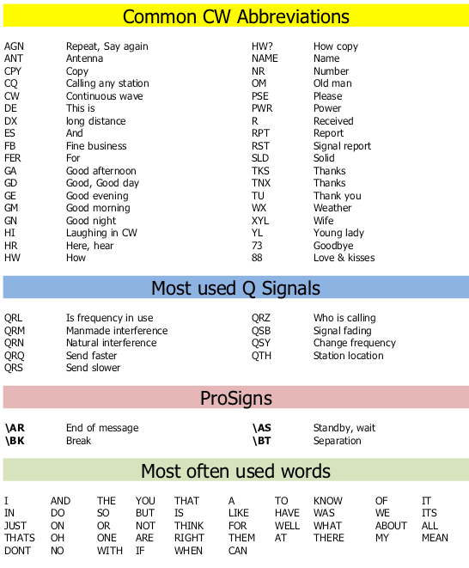
Figure 3 The most common CW abbreviations Q-codes, Prosigns, and most used words.

United States – State, Territory, and Commonwealth Abbreviations
United States – State, Territory, and Commonwealth Abbreviations
AL | Alabama |  | AK | Alaska |  | AR |  | Arkansas |  |  | AZ | Arizona
CA | California |  | CO | Colorado |  | CT |  | Connecticut |  |  | DE | Delaware
FL | Florida |  | GA | Georgia |  | HI |  | Hawaii |  |  | IA | Iowa
ID | Idaho |  | IL | Illinois |  | IN |  | Indiana |  |  | KS | Kansas
KY | Kentucky |  | LA | Louisiana |  | ME |  | Maine |  |  | MD | Maryland
MA | Massachusetts |  | MI | Michigan |  | MN |  | Minnesota |  |  | MO | Missouri
MS | Mississippi |  | MT | Montana |  | NC |  | North Carolina |  |  | ND | North Dakota
NE | Nebraska |  | NH | New Hampshire |  | NJ |  | New Jersey |  |  | NM | New Mexico
NV | Nevada |  | NY | New York |  | OH |  | Ohio Nevada |  |  | OK | Oklahoma
OR | Oregon |  | PA | Pennsylvania |  | RI |  | Rhode Island |  |  | SC | South Carolina
SD | South Dakota |  | TN | Tennessee |  | TX |  | Texas |  |  | UT | Utah
VA | Virginia |  | VT | Vermont |  | WA |  | Washington |  |  | WI | Wisconsin
WV | West Virginia |  | WY | Wyoming |  | DC |  | Washington D.C. |  |  | AS | American Samoa
GU | Guam |  | MP | Northern Mariana Is. |  | PR |  | Puerto Rico |  |  | VI | U.S. Virgin Is.
FM | Micronesia |  | MH | Marshal Islands |  | PW |  | Palau
Color Key
 |  | State |  |  | Federal District |  |  |  | Commonwealth |  |  |  | Freely Associated State
Table 13 United States – State, Territory, and Commonwealth Abbreviations.

The Most Common Procedural Signs (or Prosigns) for Morse Code
The following table shows the most commonly used procedure signs (Prosigns) used in Morse Code. When sending a Prosign your send the characters together. Prosigns like $\overline{AK}$ are shown with an overbar. You might also see them show like <SK>. Either designation is your clue to run the characters together.
Prosign | Meaning | Code symbol | Explanation
$$\overline{AR}$$ | <EOM> | ▄ ▄▄▄ ▄ ▄▄▄ ▄ | End of message. $\overline{AR}$$\overline{<AR>}$
$$\overline{AS}$$ | Stand by | ▄ ▄▄▄ ▄ ▄ ▄ | Stand by or wait. $\overline{<AS>}(Stand by)"$
$$\overline{BK}$$ | Break-In | ▄▄▄ ▄ ▄ ▄ ▄ ▄▄▄ ▄ | Emergency break-in. $\overline{<BK>}(Break-in)"$
$$\overline{BT}$$ | Pause | ▄▄▄ ▄ ▄ ▄ ▄▄▄ | Separation (pause while you are thinking). $\overline{<BT>}(Pause)"$
$$\overline{HH}$$ | Error | ▄ ▄ ▄ ▄ ▄ ▄ ▄ ▄ | Sent when you made an error and need to start over. You may here some folks using six dits instead of eight. They call this a shortcut or cut word. $\overline{<HH>}(Error)"$
$$\overline{SK}$$ | End of contact | ▄ ▄ ▄ ▄▄ ▄ ▄▄▄ | Indicates the end of the QSO or contact. $\overline{<SK>}(End of Contact)"$
Table 14 Commonly used Procedural Signs (Prosigns).

The following Prosigns are sent as normal characters with the normal 1-element spacing.
Prosign | Meaning | Code symbol | Explanation
AA | All after | ▄ ▄▄▄ ▄ ▄▄▄ | Please resend all after …$"$
AB | All before | ▄ ▄▄▄ ▄▄▄ ▄ ▄ ▄ | Please send all before …$"$
BN | All between | ▄▄▄ ▄ ▄ ▄ ▄▄▄ ▄ | Please send all between. $"$
CL | Closing station | ▄▄▄ ▄ ▄▄▄ ▄ ▄ ▄▄▄ ▄ ▄ | Shutting down station. $"$
CQ | Call any station | ▄▄▄ ▄ ▄▄▄ ▄ ▄▄▄ ▄▄▄ ▄ ▄▄▄ | General call to any station. CQ CQ CQ DE AB9MZ. $"$
DE | This is | ▄▄▄ ▄ ▄ ▄ | [his/her callsign] this is [Your callsign]. $"$
K | Over | ▄ ▄▄▄ ▄ | Over to you. $"$
SOS | Save our ship | ▄ ▄ ▄ ▄▄▄ ▄▄▄ ▄▄▄ ▄ ▄ ▄ | Calling for emergency assistance. This applies to any emergencies, not just those on ships. $"$
? | Say again | ▄ ▄ ▄▄▄ ▄▄▄ ▄ ▄ | Can be used to ask a question or to fill in missing letters. $"$  Ask how they copied what you sent. HW CPY ?  Ask to fill in missing letters in a callsign. AB9?Z
Table 15 Additional procedural signs.

CW Abbreviations
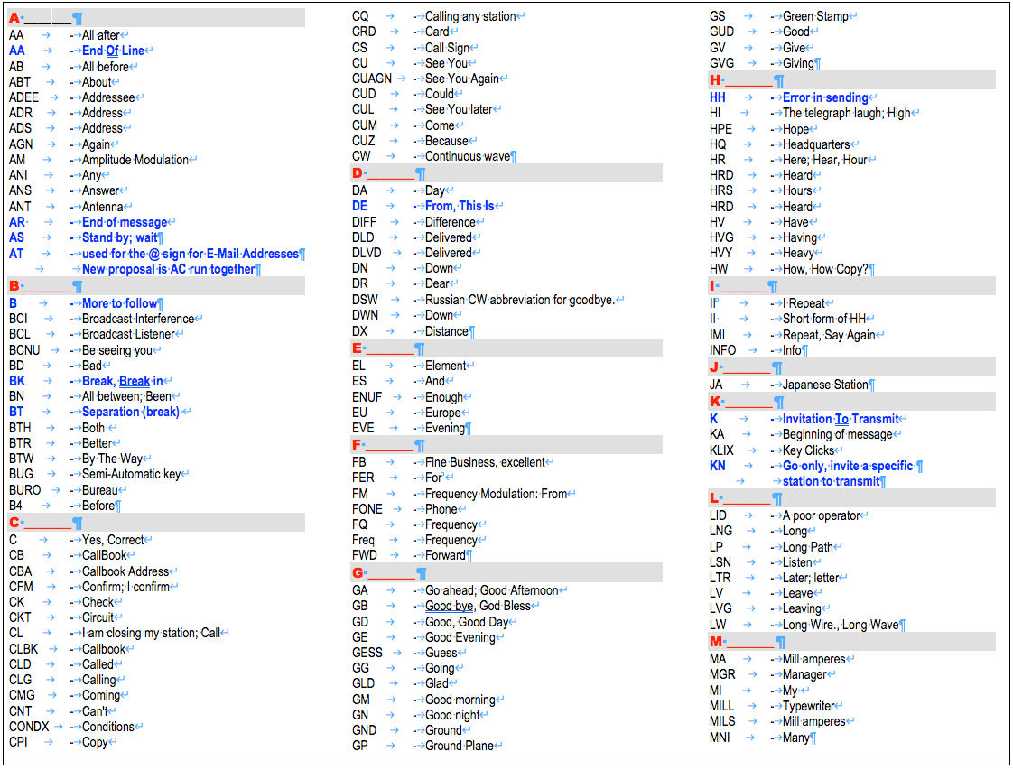
Figure 4 Full list of CW abbreviations (1 of 2).
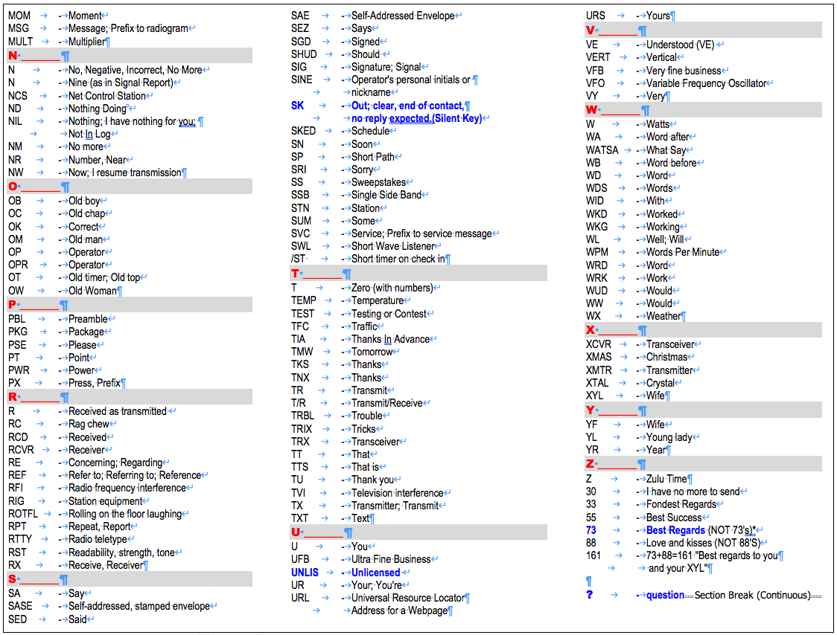
Figure 5 Full list of CW abbreviations (2 of 2).

Q-Codes
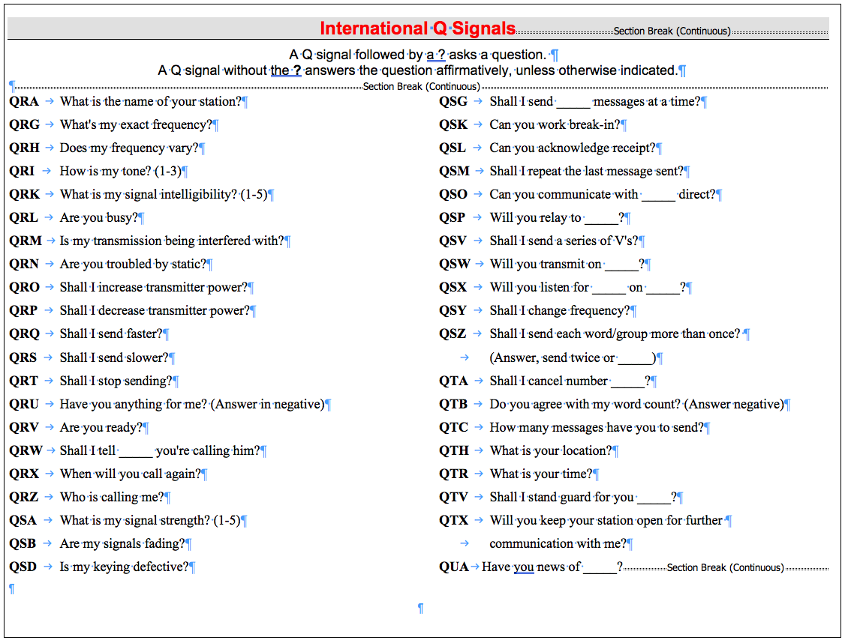
Figure 6 Q-Codes (Q-Signals).
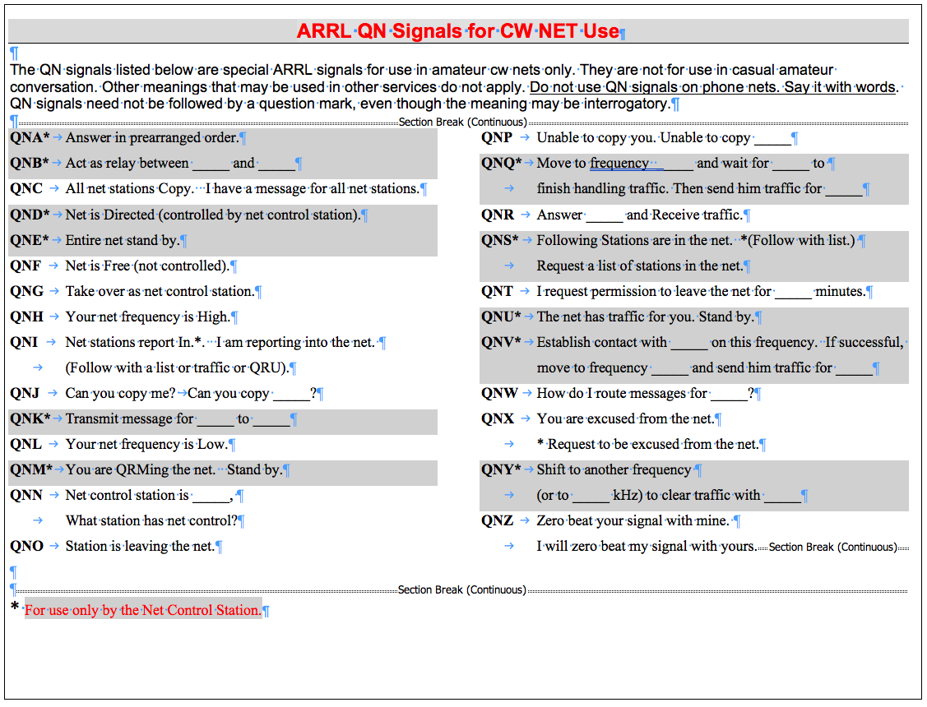
Figure 7 QN-Codes (QN-Signals)

RST (Readability Signal Tone)
Signal reports are helpful for quickly communicating how well both stations are receiving each other. For CW, the report is composed of three numbers — Readability, Signal strength, and Tone. The most common reports are 559 and 339. The first RST of 559 indicates an extremely strong signal that is perfectly copyable with perfect tone. In contrast, an RST 339 indicates a readable signal with some difficulty while copying a weak signal with perfect tone.
Signal strength and Tone numbers range from 1 to 9, while Readability ranges from 1 to 5. On occasion, an additional letter is appended to the RST. C indicates there is a Chirp, such as 559C. The letter A indicates Aurora flutter. And the letter K indicates a problem with key clicks.
Because S-meters are rarely calibrated, consider describing the Signal strength relative to your band noise, QRM, and other stations. Anything below 5 means you are having trouble hearing the other station. Strength 5, 6, or 7 means that the other station is above the general noise. S8 means the signal is well above the noise, and S9 is strong.
In contests, an RST of 599 is virtually always used. To save time you can use a cut number like 5NN instead of 599 to keep things simple and let you focus on the contest and making contacts. However, outside of contest exchanges, please consider providing honest and useful RST reports. It will help the other operator evaluate what to send, such as choosing to send critical information twice or slowing down.
When communicating with others the Readability, Signal Strength, and Tone (RST) report you give lets the other party know how their signal is being received by you. The tone signal report is only used with CW communications. It serves no purpose in voice or digital modes.
UR RST 579 579
Table 16 Use cut numbers 5NN instead of 599 during a contest.
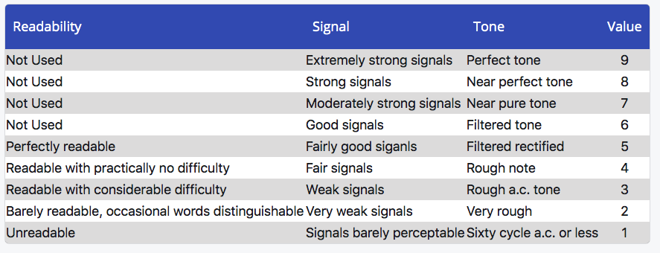
Table 17 Signal Report (Readability, Signal Strength, and Tone) (RST))

Appendix B - How to Make a Short CW Contact
CWOps Academy Advisor - Ken AC5EZ
If you call CQ, the calling sequence looks like this:
CQ CQ CQ DE [your callsign] [your callsign] K
A station answers your CQ call:
[your callsign] [your callsign] DE [his/her callsign] [his/her callsign] K
You respond:
[his/her callsign] DE [your callsign]
TNX FER CALL UR RST [your rpt] [your rpt]
NAME [your name] [your name]
QTH [your QTH] [your QTH]
HW CPY? [his/her callsign] DE [your callsign] K
The other station responds:
[your callsign] DE [his/her callsign]
TNX [your name or call sign] UR RST [his/her rpt] [his/her rpt]
NAME IS [his/her name] [his/her name]
QTH [his/her QTH] [his/her QTH]
HW CPY? [your callsign] DE [his/her callsign] K
You have an option to “say goodbye” or continue the QSO (on the next page)
Closing the QSO “saying goodbye”
Table 18 How to Make a Short CW Contact (1 of 2).

[his/her callsign] DE [your callsign]
TNX [his/name name] VY NICE TO MEET U
73 ES CUL $\overline{SK}$$\overline{<SK>}(End of Contact)"$
[his/name callsign] DE [your callsign] K
The other station might say:
[your callsign] DE [his/her callsign]
TNX [your name] FER QSO
73 [your callsign] DE [his/her callsign]
E E
And you may respond:
E E
You can continue the QSO with the following:
[his/her callsign] DE [your callsign]
Then you can respond with any or all of these lines:
Solid copy [his/her name] rig here is [your transceiver]
ANT is [your antenna] up [how high]
WX here is [temperature] deg F and [weather condition]
HW CPY? [his/her callsign] DE [your callsign] K
The other station might respond with his/her information:
When you’re finished ready to close the QSO go back to “Closing the QSO” above.
Table 19 How to Make a Short CW Contact (2 of 2).

Appendix C - Morse Code Ninja’s Advice for Beginners and Beyond
By the Morse Code Ninja

DOs
- Realize that learning Morse code is not hard. However, it takes diligent practice to become proficient. Think of it as learning to play the piano, but without taking years to become proficient.
- Learn the characters using the Koch or Farnsworth method. Try both. One approach will work better for you than the other.
- Learn the characters at a speed of 20 wpm. If using the Farnsworth method, increase the spacing between characters and words to start with an overall speed of 10 wpm. If you can count the dits and dahs, start at a higher character speed. You may need to go as high as 30 wpm.
- Develop a habit of practicing regularly. More frequent practice for shorter periods is more effective than fewer more extended sessions. Ideally, practice twice a day for 10 to 15 minutes every day.
- Set a goal for the level of proficiency you want to achieve and write it down. This simple act will improve your chances of accomplishing your goal! Read this for more details.
- Keep a log of your practice and proficiency. Look back on it when you fail to see all the progress you have made. Persistence pays off.
- If you get bored with your practice routine, change it up. Keep it fresh and fun. Perhaps practice with a friend.
- Learn to copy all the characters before learning to send. This will help you listen for the sound pattern of characters instead of counting dits and dahs.
- If you run into difficulty, seek out the help and advice of an Elmer.
- Use efficient practice methods and techniques. Some methods are not efficient compared to others and will take you longer to reach your goals. Seek out the advice of an Elmer if you do not see the progress you expect.
- Consider learning or improving your proficiency with Morse code by taking a CW Academyclass. It is a free online class where you can get personalized guidance.
- Protect your hearing! Listen to Morse code at the lowest usable volume, especially if using headphones.

DON’Ts
- Don't learn Morse code at 5 wpm!
- Don’t use Morse code sound-alikes! It is tough to let go of this mnemonic as you transition to higher speeds.
- Don't use a Morse code tree or any other kind of visual representation to learn Morse code.
- Don't memorize the sequence of dits and dahs for each character. Conscious thinking is slow compared to the unconscious mind's ability to process information. Using a lookup table is difficult, and it will prevent you from going faster than 10 to 13 wpm.
- Avoid repeating characters in your mind. Work to develop Instant Character Recognition.
- Don't learn to send without continuous evaluation of your timing. Use an elmer or software to monitor your progress. It can be challenging to break bad habits formed early on.
- Avoid becoming tense and stressed as you practice. If you miss a letter or word, let it go.

So, you want to go faster:
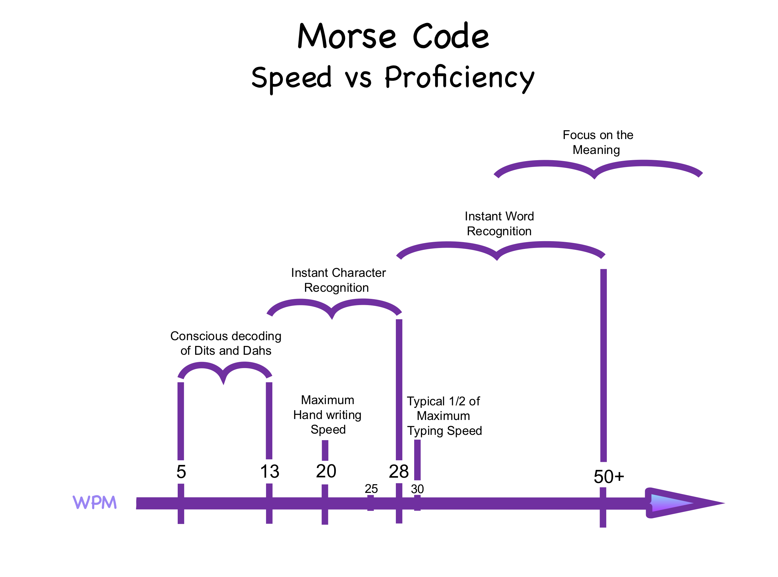
At some point in our Morse code journey, we all yearn to copy faster. However, as a reminder, accuracy should always trump speed in the real-world. If you are working at a higher speed than your proficiency or band conditions allow, at best, you may frustrate yourself and the other operator. And at worst, you may fail to communicate successfully.
Figure 8 Morse code speed vs proficiancy.
So, what does it take to go faster? In short, it requires learning to operate at a higher proficiency, as shown in the diagram to the right. Knowing this and achieving it are two different things. First, let us cover some theory, and then we will look at approaches to move from one proficiency level to the next.
There are two types of mental processes — conscious and unconscious. The conscious mind is amazing. It allows us to solve complex and difficult problems, such as a calculus homework assignment. It empowers us to engage in abstract, logical, and analytical thinking. Anytime we stop to focus and concentrate, we are almost certainly employing our conscious mind. The downside is how slow it is compared to the unconscious mind!
By comparison, the unconscious mind is lightning fast. It is effortless, automatic, and continuous. It is also where the majority of our information processing takes place. The unconscious mind feeds higher-level information to the conscious mind. For example, in everyday conversation, our unconscious mind does all of the hard work of interpreting phonemes, words, and grammatical structure. It also allows our conscious mind to focus on the meaning of what is being said, and it enables us to understand someone casually talking at 150 wpm effortlessly.
The unconscious mind's lightning-fast ability to process information is the key to copying code faster. As a general principle, as the Morse code speed increases, a larger amount of the processing and interpretation must be done by the unconscious mind. And this is directly related to the four levels of Morse code proficiency.

Levels of Morse code proficiency:
- Conscious decoding of Dits and Dahs.
- Instant Character Recognition.
- Instant Word Recognition.
- Focus on the Meaning.
Before we dive into these levels, it is helpful to understand that they are not used exclusively. It is not uncommon to shift back and forth. As an analogy, consider the act of breathing. It is nearly always under the control of the unconscious mind. But by drawing our focus to it, we may control it with our conscious mind. With enough experience, it is possible to shift our Morse code proficiency level to best match the context and speed of the code being copied. For example, a callsign must be copied character by character, while a word can be copied as a complete sound pattern.
So, what are the four proficiency levels? And how do they relate to your ability to copy at higher speeds?

1. Conscious decoding of Dits and Dahs in Your Head
At this proficiency level, you actively (conciously) listen to the dits and dahs.Once there is a word or inter-word space, the sequence of dits and dahs is looked up in your conscious mind to identify the character being sent. For example, you might hear Di-Dah-Dit, think Dit - Dah - Dit, and then look up the sequence to identify it as the letter R.
If you find yourself repeating the sound pattern in your mind, you may also be at this level.
At this basic proficiency level, the conscious mind is doing all of the work to decode and interpret the Morse code! And because the conscious mind is so much slower than the unconscious mind, you will be unable to go faster than 10 to 13 words a minute at this level.
If you learn Morse code at 5 wpm, using sound-a-likes, memorization charts, or other learning-aids, you will inevitably start your Morse code journey at this proficiency level. This is not advised since you may inevitably get stuck and unable to copy code beyond 13 wpm. Some people get stuck for years despite heroic efforts to overcome it! And others transition to higher speeds without much of a problem.

2. Instant Character Recognition (ICR)
At this level of proficiency, the unconscious mind is doing the hard work of instantly recognizing each letter as it is sent. The characters are recognized instantly and effortlessly. For example, when you hear di-dah-dit, you think of the letter R. Then the slow, conscious mind follows letter by letter to form words, abbreviations, and callsigns.
To begin learning Morse code with ICR (Instant Character Recognition), you will need to use either the Farnsworth or Koch Method.
The Koch Method is a learning technique named after German psychologist Ludwig Koch. With this method, the full target speed is used, starting with just two letters. Once strings containing those two characters can be copied with 90% accuracy, an additional character is added. This step is repeated until the full character set is mastered.
The Farnsworth method is a learning technique named after Donald R. "Russ" Farnsworth (F6TTB). With this method, you are taught to copy characters at their full and standard speed. However, the spacing is lengthened between characters and words, which gives you time to think about the sound pattern you just heard. Typically, students start with a character speed of 20 wpm and an effective speed of 10 wpm. Like the Koch method, students start with two characters and continue to add characters as soon as they reach 90% accuracy.
The key to mastering ICR with the Koch Method and Farnsworth Method is to ensure that you learn the sound pattern of characters at a speed of at least 20 wpm. If you can count the dits and dahs at 20 wpm, you will need to learn at a higher speed, probably 25 to 30 wpm. Otherwise, it is almost impossible to avoid counting the dits and dahs. And with the Farnsworth method, you will need to use an overall speed that prevents you from repeating the sound pattern in your head. Typically, an overall speed of 10 wpm is sufficient.
Does it matter how you copy with ICR? Yes! It will affect the maximum speed you can achieve, which may be anywhere from 20 to 30 wpm. There are three ways that you can copy Morse code using ICR and the previous proficiency level of Conscious Decoding of Dits and Dahs.

Pencil-Copy: With this method, each letter is written down on paper after being instantly recognized. The speed limit comes down to the fact that people cannot write very fast, and it is tiresome. Even using a modified printing style for speed, most people will only sustain 20 wpm while putting each letter down on paper.
This method is often employed at slower speeds since it does not require a computer, it is simple to learn, and it alleviates the conscious mind from having to keep track of a sequence of letters to form words and abbreviations. And it frees the conscious mind from keeping track of more higher-level statements and sentences.
Keyboard-Copy: With this method, each letter is typed on a keyboard. Instead of hearing di-dah-dit and thinking of the letter R, you associate the di-dah-dit sound pattern with pressing the letter R on a keyboard.
With keyboard-copy, the unconscious mind is doing even more of the work compared to ICR with pencil-copy. And the interpretation of the meaning often comes from reading the words and abbreviations formed on the screen! This can create an odd sensation when the conscious mind does not know what is being sent until it is read on the screen!
Keyboard-copy is faster than pencil-copy. Our continuous keyboard-copy ability will be half our steady typing speed. For instance, most proficient touch typists can sustain a typing speed of 60 wpm, which puts their maximum sustained keyboard-copy speed at 30 wpm.
Head-Copy: With this method, nothing is recorded outside of the mind's eye. Using this method with ICR, the unconscious mind does the hard work of instantly recognizing the sound patterns and prompting the conscious mind with each character. The conscious mind must then take on the hard work of following character-by-character to identify words, abbreviations, and then the higher-level meaning of statements and sentences.
If you are head copying, this method is sometimes described as the process of affixing letters on a blank blackboard or tickertape in the mind's eye as each letter is received. Then you read what is on the board. Perhaps, this description is more of an analogy than reality for most people.
Using ICR and head copy, most people will max out somewhere between 25 and 30 wpm. This maximum speed refers to continuous copying. At higher speeds, it is possible to copy a short burst of characters such as a callsign or serial number, which is often a skill developed to participate in contests at 30 to 40 wpm. The world record for unaided callsign copy is 195 wpm!!
I recommend starting your Morse code journey learning to head-copy with ICR. This will allow you to quickly achieve 25 to 30 wpm real-world speeds operating on the air, and it will enable you to progress to the next two proficiency levels.
Table 20 Copying Methods.

3. Instant Word Recognition (IWR)
At this proficiency level, the unconscious mind does most of the hard work. You hear the sound pattern of entire words and abbreviations as a whole, and then you instantly and effortlessly recognize them. While the unconscious mind does a lot of hard work, the conscious mind must keep track of words and the grammatical structure to form meaningful sentences. For example, you hear dah-di-dah-dit dah-dah-di-dah and think CQ.
This proficiency level often allows users to achieve speeds of 50 wpmor greater with enough practice, and it is nearly always done with head-copy. It is interesting to note that this level of proficiency often develops early on with real-world practice. It is common to learn the sound pattern of CQ, 599, 5NN, TEST, and your callsign without trying to learn them as sound patterns, and you can copy them at much higher speeds than anything else.
Gaining proficiency at this level is a matter of building up a vocabulary of sound patterns. Consider the following ABC's of success to master IWR (Instant Word Recognition).
The ABC's of success
- Learn the sound pattern of words and abbreviations at or slightly above your maximum ICR speed. Working at that speed will encourage you to focus on the word's entire sound pattern and not follow letter-by-letter. It's analogously to why we learn ICR at a character speed of 20 Words Per Minute (wpm) or faster — in that case, we want to avoid focusing on individual dits and dahs.
- After learning to copy the sound pattern of individual words, strive to copy two and then three words at a time. You may find my n-gram Morse code practice sets useful in developing this skill — Sets of 2 Words and Sets of 3 Words — and perhaps using them at 30wpm. They are based on the most common two and three-word combinations in the English language. And because they are so common and familiar, it helps ease copying multiple words for the first time. If you copy one of the words, you may easily guess the missing word(s).
Copying multiple words at a time is mostly a matter of giving your conscious mind enough space or mental capacity to take on the challenge of remembering several words at a time.
- After learning to copy handfuls of words at a time, strive to master copying an entire sentence. I recommend starting with the easiest sentences made up of the most common 100 words in the English language. And then move on to sentences that use larger vocabularies. You may find my practice sets — Sentences from the Top 100 Words, Sentences from the Top 200 Words, and so on — very useful.
Once you have built up a vocabulary of sound patterns at a given speed and understand them in statements and sentences, it is straightforward to increase your maximum copy speed. Diligently and incrementally, practice at ever faster speeds to reach your goal.
As a tip, if you listen to Morse code without headphones, pay close attention to any echo in the room. You may need to make adjustments to minimize echo, which can interfere with clearly hearing Morse code at or above 40 wpm.
Table 21 The ABC's of success

4. Focus on the Meaning of the Message
At this proficiency level, the unconscious mind is doing all of the hard work! The conscious mind is free to focus on the meaning of what is being sent. This level of proficiency is the nirvana that most aspire to achieve. It is equivalent to listening to someone talk to you in your primary language. It is easy and effortless.
This level of proficiency develops with extensive practice and experience. As the unconscious mind takes on ever greater responsibility, it increasingly frees up the conscious mind to focus on the meaning.
If you would like to watch my talk on Morse code Proficiency vs Speed, feel free to watch the 17-minute YouTube video below.
https://youtu.be/5BlhhBK1CBw

The Dirty Dozen:
If you are running into difficulties learning Morse code, consider the following dirty dozen. They are twelve interrelated problems caused primarily by improper teaching or self-learning techniques coupled with bad habits formed during the learning and proficiency improvement process. Most students encounter one or more of these problems through the course of gaining proficiency. (The credit for this section goes to Jack Ritter, W0UCE, Silent Key. The entire article can be found here.)
1) Anticipating what is being sent: A common problem develops when paper and pencil are used to write or print each letter as it is sent versus learning to copy complete words by their distinct rhythm and sound by ear.
For example, the letters A N Y are written down individually, and the person copying them down is focused on each letter. They have no idea of words or sentence flow. They are not learning to use Morse as a language and are merely copying down individual characters. Then if the next letter to follow ANY is W, the mind's eye anticipates ANYWAY or ANYWHERE. If a different letter than what is expected follows, their focus is diverted. This is the problem with anticipation.
The most efficient way to overcome anticipation is to learn to recognize complete words by their unique sound and rhythm while learning to copy by ear and copying behind. Practice identifying the sound and rhythm of the most common double letter, two and three letter combinations based upon the frequency of usage in the English language helps to form word sounds.
- Common double letter combinations:
ll, ee, ss, tt, oo, mm, ff, pp, rr ,nn, cc, dd.
- The thirty most frequent two-letter combinations comprise one third of all letter usage:
th, he, in, er, an, re, on, en, at, es, ed, te, ti, or, st, ar, nd, to, nt, is, of, it, al, as, ha, ng, co, se, me, and de.
- The most common three-letter combinations are:
the, and, tio, ati, for, tha, ter, res, ere, con, ted, com, hat, ent, ion, nde, has, ing.
2) Attention loss, lack of accuracy: Attention loss is often related to Problem 10 during the learning phase and often causes frustration. Practice sessions should not exceed thirty minutes in duration. Break up practice sessions in ten or fifteen-minute increments. And practice thirty minutes a day, seven days a week.
Lack of accuracy is related to Problems 1, 3, 4, 6, 7, and 10. There is no substitute or better way to learn and improve proficiency than learning to copy by ear and only take notes versus putting individual characters on paper. Practices learning the sound of short words then progress to short phrases such as my dog. Then add a follow-on word to start building phrases and sentences. Common QSO exchanges help build confidence to get on the air.
3) Counting Dits and Dahs: Learning Morse code by counting Dits and Dahs is a terrible habit that is difficult to break. Counting is typically caused by learning Morse at 5 or 10 words per minute character speed. While some instructors endorse using the Farnsworth method, adding extra space between characters often leads to unintentional counting. And a long delay can allow a student to replay the sound pattern in their head. (Counting is directly related to Problems 7, 8, 9, and 12.)
Consider starting with a 20 wpm character speed with a bit of extra space between short words. For example, TEA followed by EAT. Then progress to three-word phrases. Eliminate extra spaces between words as quickly as possible to learn and use Morse with normal speed and spacing. Why teach or learn at 5 or 10 wpm when it just as easy to learn at 20 wpm.
4) Dit and Dah Transposition: Transposition is primarily related to learning at slow character speed and tone frequency being either too low or too high for an individual’s hearing frequency range. The most common character reversals or transposition are: er-re, es-se, an-na, it-ti, on-no, en-ne, ot-to, ed-de, st-ts, at-ta, ar-ra, in-ni.
To overcome the problem of transposition, practice copying and sending the numbers 1 through 10.
5) Inability to break old habits: The obvious answer to overcoming this problem is not to develop bad habits in the first place! Bad habits developed in the early learning stage are the most difficult to overcome.
The key to breaking old habits is to focus on exercises, methods, and techniques that help overcome or break specific old habits. The first step is to determine what bad habits individuals have and make a list. Then focus on overcoming the worst bad habit or habits first. Develop a plan and follow it.
6) Inability to copy behind: This problem is directly related to Problem 12. Until students or those with experience "break the pencil and toss out the paper" and learn to copy entire words by their distinct sound and rhythm, this problem will automatically become problem 5, 8, 9 and 10. And this problem must be broken to become proficient and use Morse code as a language.
To overcome this problem, set up exercises comprised of short word phrases. Repeat two or three times if necessary and practice retaining phases such as MY RED HAT, HER OLD CAT, BIG BAD BEN, UR RST 599, MY RIG IS A K3.
7) Inability to distinguish spaces and timing: This problem is usually related to learning to copy at slow speed and copying individual letters versus words. Concerning sending, we can tune the bands most any day and hear poorly formed code. This sender is said to have a "bad fist."
While an experienced instructor will not encourage using code readers, new radios such as the Elecraft K-3 can display Morse as it is sent. Students can benefit by using a Morse display actually to see that they are sending with proper character spacing and timing. Watching a display while practicing sending helps overcome spacing and timing issues.

8) Increasing speed: This problem concerns copying and is directly related to every other problem on the Dirty Dozen List. Identify and address each problem individually. This will make increasing speed easier to achieve.
Then if you are still stuck, consider that most everyone reaches a "plateau" or bump in the road where they seem to be stuck at a certain speed. To overcome problems with a given plateau or bump in the road, "jump the bump." For example, if you are stuck at 20 wpm, increase the speed to 21 or 22 wpm. Increasing the speed by even one or two words per minute is the best way to increase receiving speed proficiency.
9) Lack of confidence: This problem is usually related to "getting on the air" and making QSOs. One way to gain confidence is to have QSOs with yourself. Use a code practice oscillator or key the sidetone on a transceiver without going on air. Make up a list of QSO exchanges using different call signs, names, and QTH, and then use it to practice with yourself.
Even if contesting is not something an individual wants to do, they are excellent confidence builders as the exchanges are short (except for the Sweepstakes) and there are plenty of state QSO parties to take part in. Practice makes perfect.
10) Mental fatigue: This problem is common with many activities and practicing Morse code is no different. Too much too often is not productive. Don’t practice when you are tired or just after coming home from a hard day at work. Consider practicing when relaxed, early in the morning when you are fresh, or whenever you have a genuine desire to practice. The latter being the best time. Contest or Radio Sport participants are well aware of what a toll fatigue can do to their performance. Don’t overdo it.
11) Memorization versus hearing words: This problem is directly related to problems 1, 2, 3, 4, 6, and 7. Until individuals develop the ability to recognize complete words by their sound and rhythm, copying behind, and use Morse as a language, this problem will remain on their bad habit list. To overcome this problem practice copying by ear and copying behind.
12) Writing or typing each letter as it is heard: This problem is the significant obstacle standing in the way of becoming proficient in Morse code. It is our worst enemy and by all means, the first bad habit to break. Break the pencil and toss out the writing pad to learn to copy by ear and copy behind. It should be the number one priority for every beginner or anyone with the desire to improve their skill in using Morse code. Learn to use it as a language; this is a rule of thumb to live by.
Table 22 The Dirty Dozen.

Appendix D - Morse Code History
Source: https://en.wikipedia.org/wiki/Morse_code#Development_and_history
Early in the nineteenth century, European experimenters made progress with electrical signaling systems, using a variety of techniques including static electricity and electricity from Voltaic piles producing electrochemical and electromagnetic changes. These experimental designs were precursors to practical telegraphic applications.
Following the discovery of electromagnetism by Hans Christian Ørsted in 1820 and the invention of the electromagnet by William Sturgeon in 1824, there were developments in electromagnetic telegraphy in Europe and America. Pulses of electric current were sent along wires to control an electromagnet in the receiving instrument. Many of the earliest telegraph systems used a single-needle system which gave a very simple and robust instrument. However, it was slow, as the receiving operator had to alternate between looking at the needle and writing down the message. In Morse code, a deflection of the needle to the left corresponded to a dot and a deflection to the right to a dash. By making the two clicks sound different with one ivory and one metal stop, the single needle device became an audible instrument, which led in turn to the Double Plate Sounder System.

Morse code receiver, recording on paper tape
The American artist Samuel F. B. Morse, the American physicist Joseph Henry, and Alfred Vail developed an electrical telegraph system. It needed a method to transmit natural language using only electrical pulses and the silence between them. Around 1837, Morse, therefore, developed an early forerunner to the modern International Morse code. William Cooke and Charles Wheatstone in Britain developed an electrical telegraph that used electromagnets in its receivers. They obtained an English patent in June 1837 and demonstrated it on the London and Birmingham Railway, making it the first commercial telegraph. Carl Friedrich Gauss and Wilhelm Eduard Weber (1833) as well as Carl August von Steinheil (1837) used codes with varying word lengths for their telegraphs. In 1841, Cooke and Wheatstone built a telegraph that printed the letters from a wheel of typefaces struck by a hammer.
The Morse system for telegraphy, which was first used in about 1844, was designed to make indentations on a paper tape when electric currents were received. Morse's original telegraph receiver used a mechanical clockwork to move a paper tape. When an electrical current was received, an electromagnet engaged an armature that pushed a stylus onto the moving paper tape, making an indentation on the tape. When the current was interrupted, a spring retracted the stylus and that portion of the moving tape remained unmarked. Morse code was developed so that operators could translate the indentations marked on the paper tape into text messages. In his earliest code, Morse had planned to transmit only numerals and to use a codebook to look up each word according to the number which had been sent. However, the code was soon expanded by Alfred Vail in 1840 to include letters and special characters so it could be used more generally. Vail estimated the frequency of use of letters in the English language by counting the movable type he found in the type-cases of a local newspaper in Morristown, New Jersey. The shorter marks were called "dots" and the longer ones "dashes", and the letters most commonly used were assigned the shorter sequences of dots and dashes. This code, first used in 1844, became known as Morse landline code or American Morse code.

Comparison of historical versions of Morse code with the current standard.
- American Morse code as originally defined.
- The modified and rationalized version used by Gerke on German railways.
- The current International Telecommunications Union (ITU) standard.
In the original Morse telegraphs, the receiver's armature made a clicking noise as it moved in and out of position to mark the paper tape. The telegraph operators soon learned that they could translate the clicks directly into dots and dashes, and write these down by hand, thus making the paper tape unnecessary. When Morse code was adapted to radio communication, the dots and dashes were sent as short and long tone pulses. It was later found that people become more proficient at receiving Morse code when it is taught as a language that is heard, instead of one read from a page.
To reflect the sounds of Morse code receivers, the operators began to vocalize a dot as "dit", and a dash as "dah". Dots which are not the final element of a character became vocalized as "di". For example, the letter "c" was then vocalized as "dah-di-dah-dit". Morse code was sometimes facetiously known as "iddy-umpty" and a dash as "umpty", leading to the word "umpteen".
The Morse code, as it is used internationally today, was derived from a much-refined proposal by Friedrich Clemens Gerke in 1848 that became known as the "Hamburg alphabet". Gerke changed many of the codepoints, in the process doing away with the different length dashes and different inter-element spaces of American Morse, leaving only two coding elements, the dot and the dash. Codes for German umlauted vowels and "ch" were introduced. Gerke's code was adopted by the Deutsch-Österreichischer Telegraphenverein (German-Austrian Telegraph Society) in 1851. This finally led to the International Morse code in 1865. The International Morse code adopted most of Gerke's codepoints. The codepoints for "O" and "P" were taken from Steinheil's code. A new codepoint was added for "J" since Gerke did not distinguish between "I" and "J". Changes were also made to "X", "Y", "Z". This left only four codepoints identical to the original Morse code, namely "E", "H", "K" and "N", and the latter two have had their dashes lengthened. The original code being compared dates to 1838, not the code shown in the table which was developed in the 1840s.
In the 1890s, Morse code began to be used extensively for early radio communication before it was possible to transmit voice. In the late 19th and early 20th centuries, most high-speed international communication used Morse code on telegraph lines, undersea cables and radio circuits. In aviation, Morse code in radio systems started to be used on a regular basis in the 1920s. Although previous transmitters were bulky and the spark gap system of transmission was difficult to use, there had been some earlier attempts. In 1910, the US Navy experimented with sending Morse from an airplane. That same year, a radio on the airship America had been instrumental in coordinating the rescue of its crew. Zeppelin airships equipped with radio were used for bombing and naval scouting during World War I, and ground-based radio direction finders were used for airship navigation. Allied airships and military aircraft also made some use of radiotelegraphy. However, there was little aeronautical radio in general use during World War I, and in the 1920s, there was no radio system used by such important flights as that of Charles Lindbergh from New York to Paris in 1927. Once he and the Spirit of St. Louis were off the ground, Lindbergh was truly alone and incommunicado. On the other hand, when the first airplane flight was made from California to Australia in 1928 on the Southern Cross, one of its four crewmen was its radio operator who communicated with ground stations via radio telegraph.
Beginning in the 1930s, both civilian and military pilots were required to be able to use Morse code, both for use with early communications systems and for identification of navigational beacons that transmitted continuous two- or three-letter identifiers in Morse code. Aeronautical charts show the identifier of each navigational aid next to its location on the map.
Radiotelegraphy using Morse code was vital during World War II, especially in carrying messages between the warships and the naval bases of the belligerents. Long-range ship-to-ship communication was by radio telegraphy, using encrypted messages because the voice radio systems on ships then were quite limited in both their range and their security. Radiotelegraphy was also extensively used by warplanes, especially by long-range patrol planes that were sent out by those navies to scout for enemy warships, cargo ships, and troop ships.
In addition, rapidly moving armies in the field could not have fought effectively without radiotelegraphy because they moved more rapidly than telegraph and telephone lines could be erected. This was seen especially in the blitzkrieg offensives of the Nazi German Wehrmacht in Poland, Belgium, France (in 1940), the Soviet Union, and in North Africa; by the British Army in North Africa, Italy, and the Netherlands; and by the U.S. Army in France and Belgium (in 1944), and in southern Germany in 1945.

A U.S. Navy Morse Code training class in 2015. The sailors will use their new skills to collect signals intelligence.
Morse code was used as an international standard for maritime distress until 1999 when it was replaced by the Global Maritime Distress and Safety System. When the French Navy ceased using Morse code on January 31, 1997, the final message transmitted was "Calling all. This is our last cry before our eternal silence."[26] In the United States the final commercial Morse code transmission was on July 12, 1999, signing off with Samuel Morse's original 1844 message, "What hath God wrought", and the prosign "<SK>" ("end of contact").
As of 2015, the United States Air Force still trains ten people a year in Morse. The United States Coast Guard has ceased all use of Morse code on the radio, and no longer monitors any radio frequencies for Morse code transmissions, including the international medium frequency (MF) distress frequency of 500 kHz. However, the Federal Communications Commission (FCC) still grants commercial radiotelegraph operator licenses to applicants who pass its code and written tests. Licensees have reactivated the old California coastal Morse station KPH and regularly transmit from the site under either this call sign or as KSM. Similarly, a few U.S. museum ship stations are operated by Morse enthusiasts.

Appendix E - Here are some commonly heard CW sender spacing errors
The following is taken from “The FOC Guide to Morse Code Proficiency” by Gary Hinson, ZL2iFB Version 1.4 January 2019
https://g4foc.org/resources/Documents/FOC_Guide_to_Morse_Code_Proficiency_v1.4.pdf

Ti ming is ever y thing
Speaking of pianists, if a musician played a well-known piece of music with all the correct notes in the correct sequence but wrongly timed, it would be hard for listeners to figure out what was being played. In effect, the tune would be lost. Timing is a critical factor with Morse too, one that deserves more emphasis when we are learning the code or aiming to improve. Morse code comprises defined sequences of three elements: dots (normally spoken as “dits” to emphasize their shortness), dashes (“dahs” - longer sounds) and spaces of various lengths. All three are important. Properly formed Morse characters have the correct element lengths and spacings, consistently, with little if any fluctuation. They sound musical, with a fixed pitch and a natural rhythm, cadence or flow.
- CQCQCQCQCQCQ with no letter spaces.
- C QC QC QC QDE with word spaces off set.
- CallCall instead of Call Call - this can be particularly troublesome if the combined string contains several possible callsigns: which is the correct one? AB9MZAB9MZ vs AB9MZ AB9MZ
- DROM instead of DR OM meaning dear old man. This word puzzled me for months after I got my license until a friend explained, and we still laugh about it to this day!
- AR K instead of just $\overline{AR}$ or $\overline{AR}$ K - that delayed K tends to double with the start of the next over, perhaps interrupting the other person’s sending if they are using QSK (full break-in).
- AR instead of $\overline{AR}$ and BT instead of $\overline{BT}$.

Sending Proficiency
For successful communication, strive for a high level of sending proficiency. Consider evaluating yourself or having an experienced CW operator evaluate your sending across these five criteria. It will provide critical feedback on where to focus your improvement efforts.
Attribution goes to Gary ZL2IFB. With his permission, I have reproduced this chart. Please consider reading his FOC Guide to Morse Code Proficiency for an in-depth review on Speed, Timing, and much more!
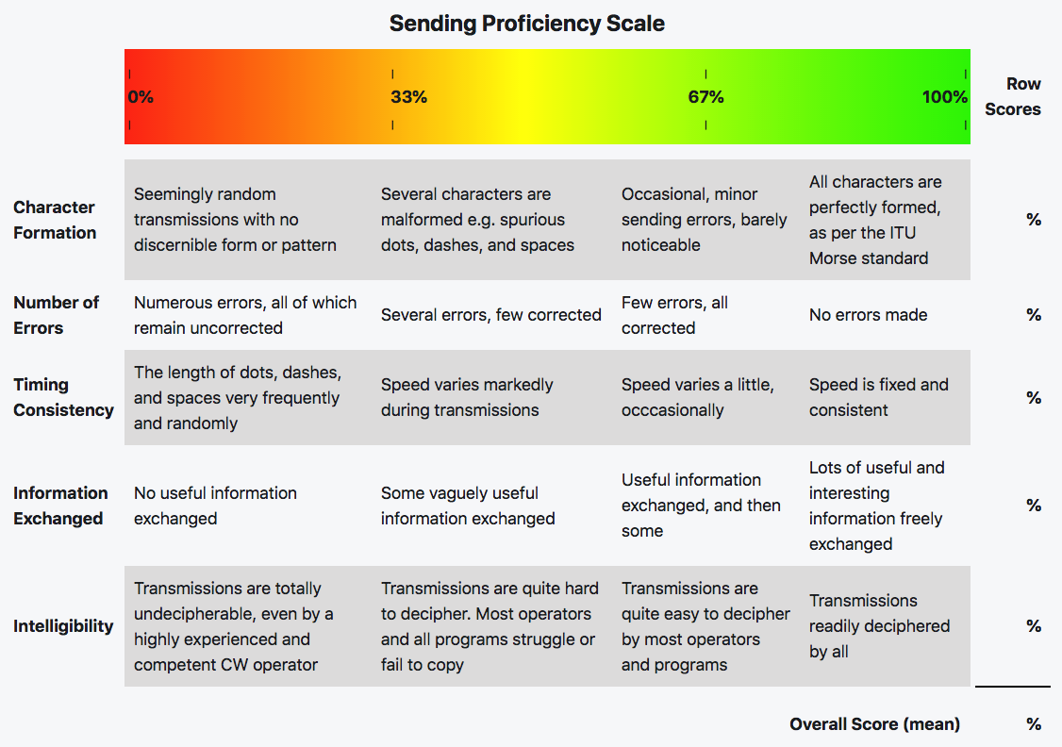

Appendix F– Other CW References
Gary Hinson, ZL2iFB. “The FOC Guide to Morse Code Proficiency” Version 1.4 January 2019
The following references are from the above document.
ARRL (2017). “Ham Radio History”. Retrieved July 15th.
DJ5IL (2017). “All About Squeeze-Keying”. Retrieved July 14th.
G3SXW (1990). “JOINEDUPSENDING”, FOC Journal #2, Spring.
ITU (2009). “International Morse code”. Recommendation ITU-R M.1677.1
K3WWP (2017). “The Streak: 23 Years of Daily Contacts”. QST, August.
KE3Z (1990). “A Standard for Morse Timing Using the Farnsworth Technique”, QEX April.
N0HFF (2001). “The Art and Skill of Radio Telegraphy: A Manual For Learning, Using, Mastering And Enjoying The International Morse Code As A Means Of Communication”. William G. Pierpont, 3rd edition.
N4BPQ (2015). “What's up with the Vibroplex Bug Morse key's unique sound?”. YouTube video.
Wikipedia (2017a). “Wabun code”. Retrieved November 29th .
Wikipedia (2017b). “American Morse code”. Retrieved November 29th .
Wikipedia (2017c). “Morse code”. Retrieved July 10th .
Wolchover, Natalie (2012). “Breaking the Code: Why Yuor Barin Can Raed Tihs”. Live Science, February 9th .
K5LN (2015). “Morse Code - An Overview”. YouTube videos: part 1, part 2, part 3 and part 4.

Books
Updated 2021-02-10
Here is a collection of books I found on the Internet and . or Amazon.com.
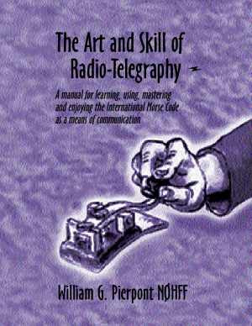 |  | The Art & Skill of Radiotelegraphy.  By William G. Pierpont, N0HFF (SK)  Copyright © 2002-04-20 This contains much information on learning Morse to a very high standard and is essential reading for anyone with an interest in Morse code. (Free) | 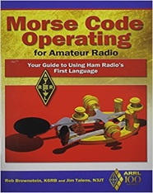 |  | Morse Code Operating for Amateur Radio  By ARRL, Inc.  Copyright © April 29, 2013  $15.95
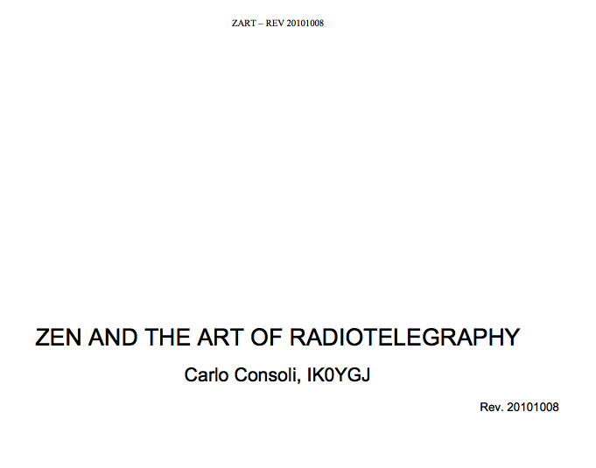 |  | Zen and the Art of Radiotelegraphy  By Carlo Consoli, IK0YGJ  Copyright © 2010-09-08 This is a Morse tutor book with an emphasis on the psychology. (Free) | 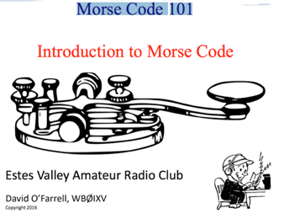 |  | Morse Code 101 – Introduction to Morse Code  Estes Valley Amateur Radio Club  By David O’Farrell, WBØIXV  Slide set - Copyright © 2016
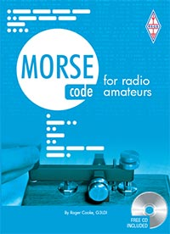 | Morse Code for Radio Amateurs (W/ CD)  By Roger Cooke, G3LDI via RSGB  12th Edition, 64pages, ISBN: 9781 9101 9319 8  Sorry Currently Out of Print. You can find this occasionally on Amazon Marketplace or other used book sellers. The 1st edition was published in 1947. |  | 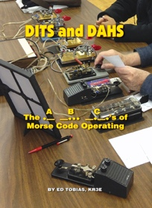 | DITS and DAHS: The ABC’s of Morse Code Operating By Ed Tobias, KR3E via CQ Communications  This small but solid guide is the perfect read for those interested in learning or improving CW operating techniques! Copyright © 2017.  $18.95 (includes shipping charge)
The Morse Code Trainer
By Steve WK5S, John K5JHF, and Kees K5BCQ 11 Feb 2018 Rev A04 Copyright © 2018
Reaching the pinnacle of CW Operations! Finally, an all-in-one tool for learning and increasing Morse code operations. The Morse Code Trainer enhances the learning experience by immersing the user in word sounds, and how to send words correctly. It also contains the smoothest and most responsive Keyer available and the one and only tool all experienced CW operator must have to enhance their proficiency and operating skills. The Morse Code Trainer will put the DX world, Contesting, and Rag Chewing at your fingertips!
Table 23 Books about Morse Code.

Appendix G - CW Reverse Beacon Network

CW Reverse Beacon Network
http://www.reversebeacon.net
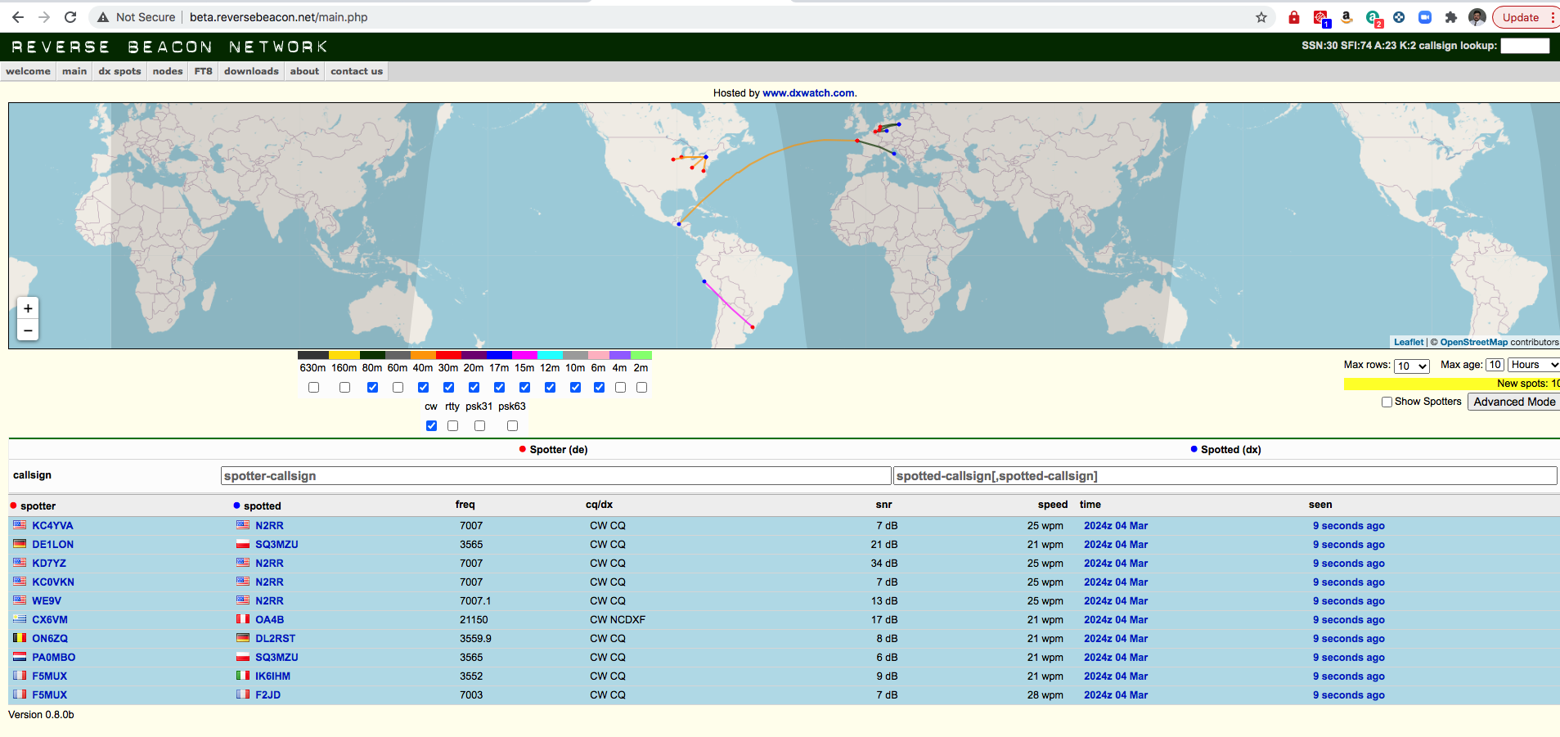
Figure 9 CW Reverse Beacon Network.
CW Reverse Beacon Network - How to Guide
https://www.hamsci.org/cw-reverse-beacon-network-how-guide
For further information, watch the RBN blog and the RBN-OPS group on groups.io: https://groups.io/g/RBN-OPS

Reverse Beacon Network
https://www.ncdxf.org/beacon/RBN.html
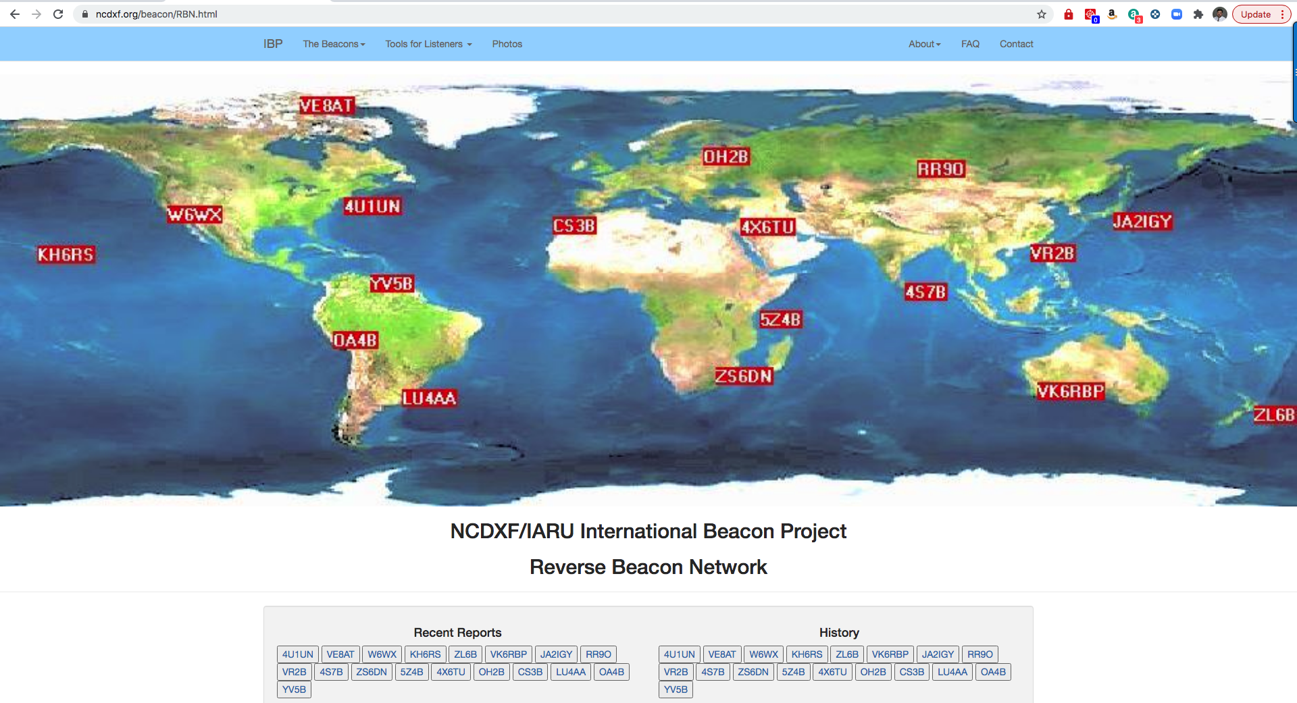
Figure 10 NCDXF Reverse Beacon Network

What Beacons are Being Heard?
There are three ways to determine which beacons are being heard in various parts of the world. You can check for reception reports (spots) made manually by amateurs who have heard the beacons and have posted a spot on a local DX Cluster or directly to DX Summit. Or you can check with web pages showing automated reception reports of the beacons by Faros software or the Reverse Beacon Network.

Appendix H - Acknowledgements
No one person is an expert on everything. I will be the first person to tell you that I am still at the beginning of my new CW journey. It didn’t matter that I learned the code and used it on 10 meters in the late ‘60s. I frankly learned it the wrong way. Now I am slowly undoing my bad habits thanks to CWOps Academy.
- I offer my undying gratitude to CWOps Academy for the wonderful classes they run and all of the thoughtfully curated resources they provide to their students. I can’t recommend their classes and mentoring enough.
- I want to especially thank Ken AC5EZ who was our CWOps Academy Advisor for his excellent mentoring during the January / February 2021 Beginners class.
- I further wish to thank Brian Davis (W9HLQ) and Kurt (W9FMC) for their efforts in reviewing this document and giving me the excellent feedback, they provided.
- Thanks to the Morse Code Ninja Kurt AD0WD for reviewing this document and providing additional suggestions.

INDEX

Abbreviations
73 (Best Regards) 33
ANT (Antenna) 33
CQ (Calling any station) 32
CUL (See You Later) 33
E (End of QSO 33
ES (AND) 33
FER ( For) 32
HW CPY? 33
HW CPY? (How did you copy?) 32
K (Over) 33
QSO (Contact) 33
QTH (Your location) 32
TNX (Thanks) 32, 33
U (You) 33
UR RST 32
VY (Very) 33
WX (Weather) 33
CW Copy Methods
Head-Copy 39
Keyboard-Copy 39
Pencil-Copy 39
CW Learning Methods
Farnsworth 9, 17, 34, 38, 43
Koch 17, 34, 38
CW Recognition Methods
Concscious decoding of Dits and Dahs 37
Focus on the Meaning 41
ICR See Instant Character Recognition
Instant Character Recognition 38
Instant Word Recognition 40
IWR See Instant Word Recognition.
CW Speed
10 to 13 wpm 35
10 wpm 34, 38
150 wpm 36
195 wpm 39
20 to 30 wpm 38
20 wpm 34, 38, 43, 44
21 or 22 wpm 44
25 to 30 wpm 9, 38, 39
25 wpm 20
30 to 40 wpm 39
30 wpm 34
30 wpm 39
40 wpm 40
5 or 10 wpm 43
5 to 40 wpm 18
5 wpm 35, 37
50 wpm 40
60 wpm 39
Beyond 13 wpm 37
Words Per Minute 40
wpm See Words Per Minute
Prosigns
? (Say again) 26
$<AR>$ (EOM) 25
$<AS>(Stand by)$ 25
$<BK>(Break-in)$ 25
$<BT>(Pause)$ 25
$<HH>(Error)$ 25
$<SK>(End of Contact)$ 25, 33
AA (All after) 26
AB (All before) 26
BN (All between) 26
CL (Closing station) 26
CQ (Calling any station) 26
DE (This is) 26, 32, 33
K (Over) 26, 32
SOS (Save our ship) 26
RST
599 40
5NN 31, 40
UR RST 579 579 31
UR RST 599 43

